
MAX7

LEVEL 2 MODULE
Level 2 | Max7 Kids Module – Making Active Disciples
Level 2 | 6 – 9 hours
Level 2 |  | MODULE TOPIC | TIME | PAGE
Level 2 | M2.1 | Using Max7Kids curriculum resources | 90 minutes | 2
Level 2 | M2.2 | Skills in running a group | 90 minutes | 6
Level 2 | M2.3 | 7 ways training | 90+ minutes | 11
Level 2 | M2.4 | Creative and Technical skills training (Optional) | Yet to be written
Level 2 | M2.5 | Strategic planning | Yet to be written
Level 2 | M2.6 | Discipling in a Family | 60-75 minutes

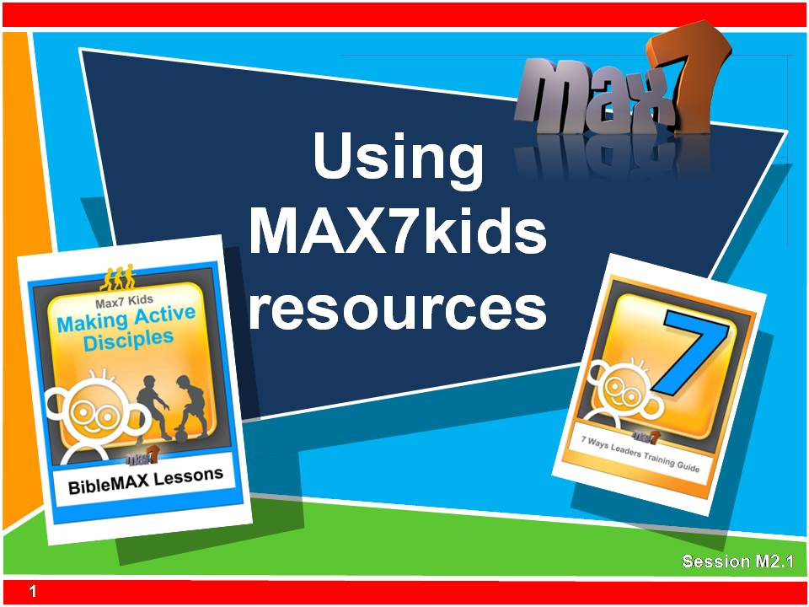
M2.1

Using max7kids curriculum resources

90 minutes

outcome

At the end of this module participants will be able to understand the structure of a Max7kids (BibleMAX) lesson and be able to run one themselves confidently.

STEPS IN THE LESSON

1. Demonstrate lesson 55 min

2. Deconstruct the BibleMAX lesson 10 min

3. How the lesson flows 10 min

4. Leaders toolbox 15 min

5. Personal reflection 5 min

WHAT YOU WILL NEED
- Choose a BibleMAX lesson and prepare all necessary equipment
- Bibles
- Video projector and sound
- Worksheet
- Flip chart
Using max7kids curriculum resources
session outline
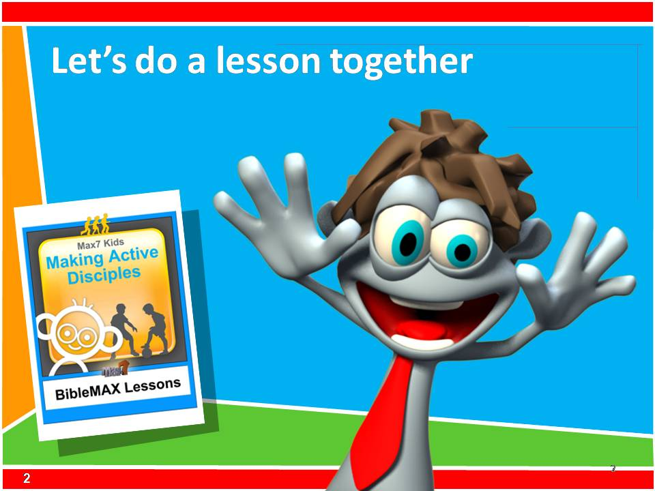
- 1.Demonstrate lesson 55 min
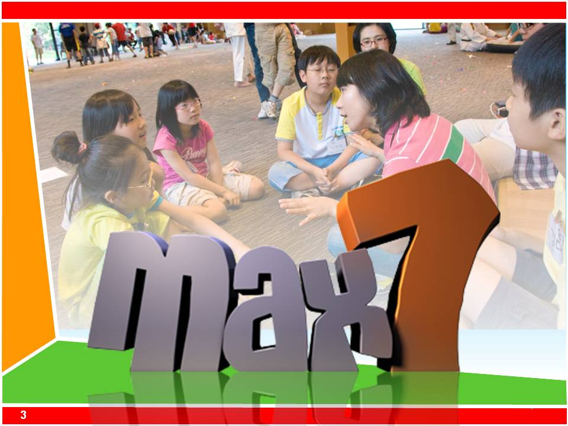
The best way for you to understand a lesson is for you to experience it. We will go through a lesson together and then discuss it and look at its structure together. Please involve yourself in the lesson like children but don’t ‘misbehave’ as children.
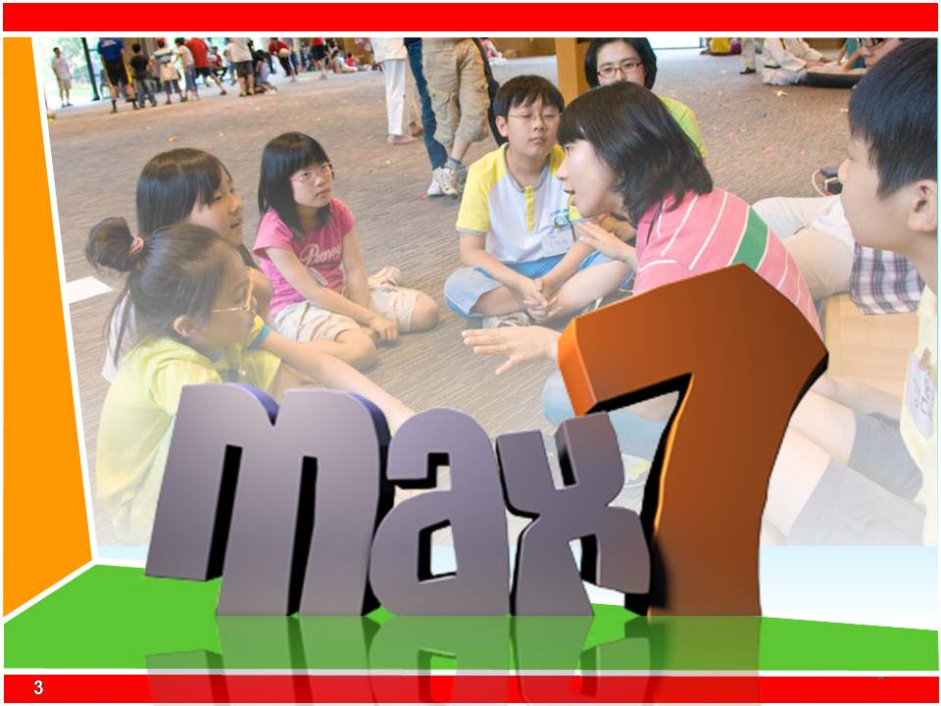
With a small team of leaders, go through a lesson from the Gospel pack or another pack. Keep the activities short and the program moving quickly so it can be completed in 50-60 minutes.
Run the lesson and then discuss these questions together. Model team leadership.
- 2. Deconstruct the BibleMAX lesson 10 min
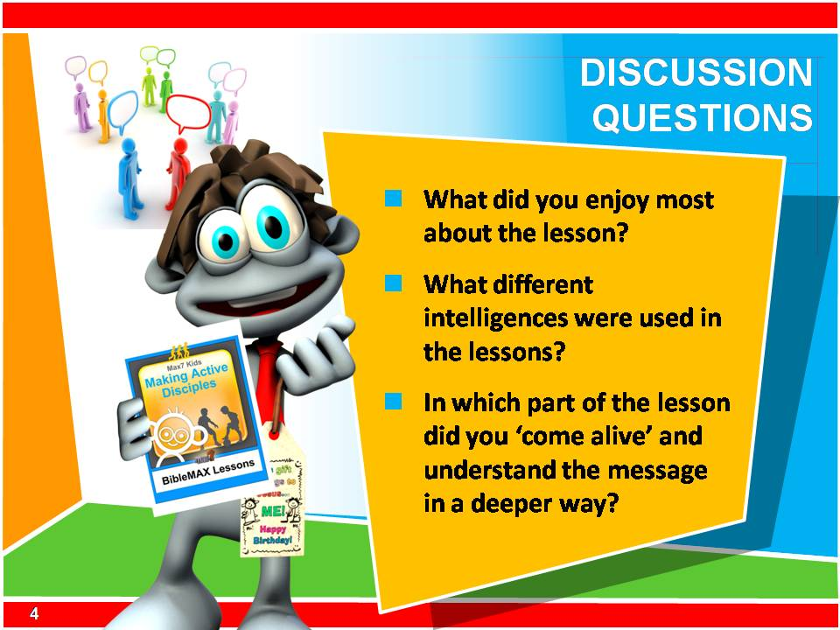
    - Debrief the lesson 
- What did you enjoy most about the lesson?
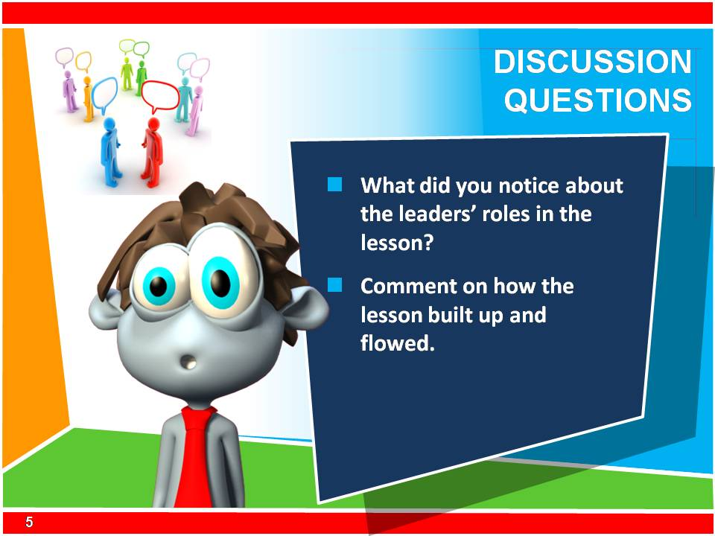
- Think back to the module on how we learn. What different intelligences were used in the lessons?
- In which part of the lesson did you ‘come alive’ and understand the message in a deeper way?
- What did you notice about the leaders’ roles in the lesson?
- Comment on how the lesson built up and flowed.
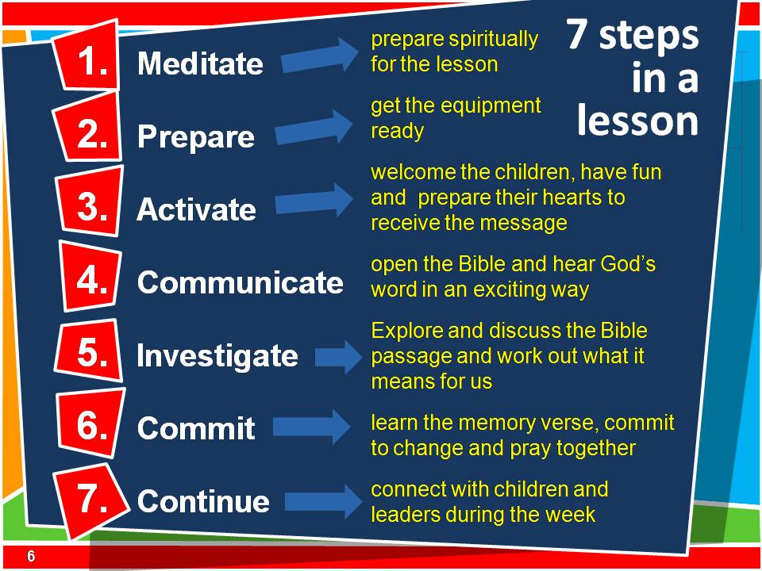
- 3. How the lesson flows 10 min
Look at the PowerPoint slide and see how the lesson flows.
    - 7 steps of the lesson
Ask 7 volunteers to hold up pieces of card or paper with each of the 7 lessons steps written on them. Explain each step to the group. Alternatively, you can use the diagram of the flow of the lesson as illustrated on the next page. Use this to explain the steps in the lesson.
Before the Lesson.
- Meditate - prepare spiritually for the lesson
- Prepare - get the equipment ready
The lesson
- Activate - welcome the children, have fun and prepare their hearts to receive the message
- Communicate - open the Bible and hear God’s word in an exciting way
- Explore or Investigate - discuss the Bible passage and work out what it means for us
- Commit - learn the memory verse, commit to change and pray together
After the lesson
- Continue - connect with children and leaders during the week
The BibleMAX provides the structure and Biblical basis of the lesson, while the leaders using the 7Ways Guide find activities that help the lesson flow. The lesson structure and content can be adapted for any group of children and leaders.
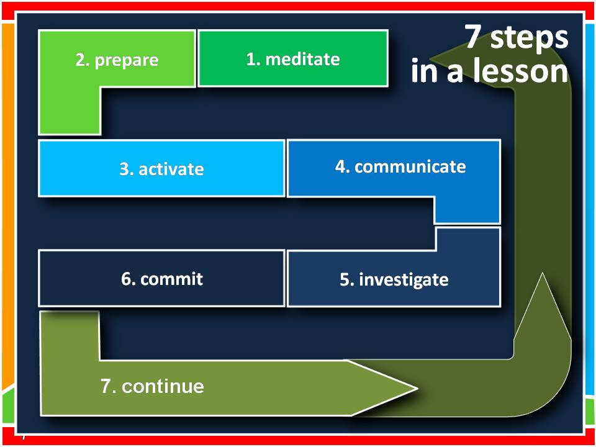
    - Show the flow of the lesson
Explain how the lesson is a journey through the 7 steps as seen in the diagram below and on the PowerPoint slide.
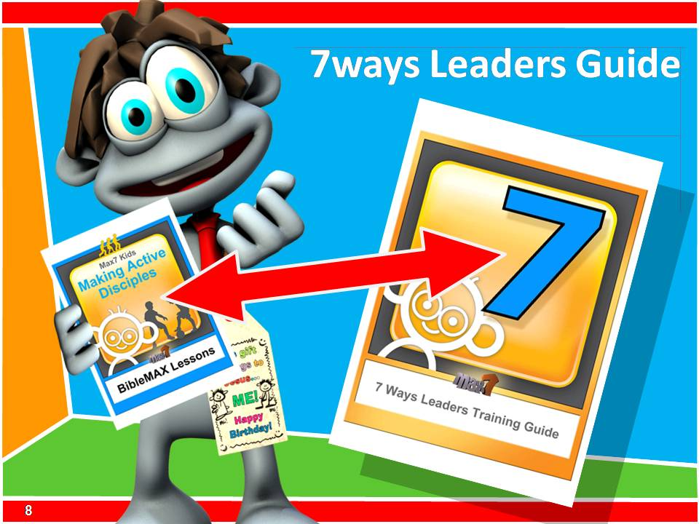
    - 7Ways in the lesson
There are many options for how each part of the lesson is completed with children.’
The leaders used the 7Ways Guide to help them put the lesson together. The 7 Ways included ideas on how to:
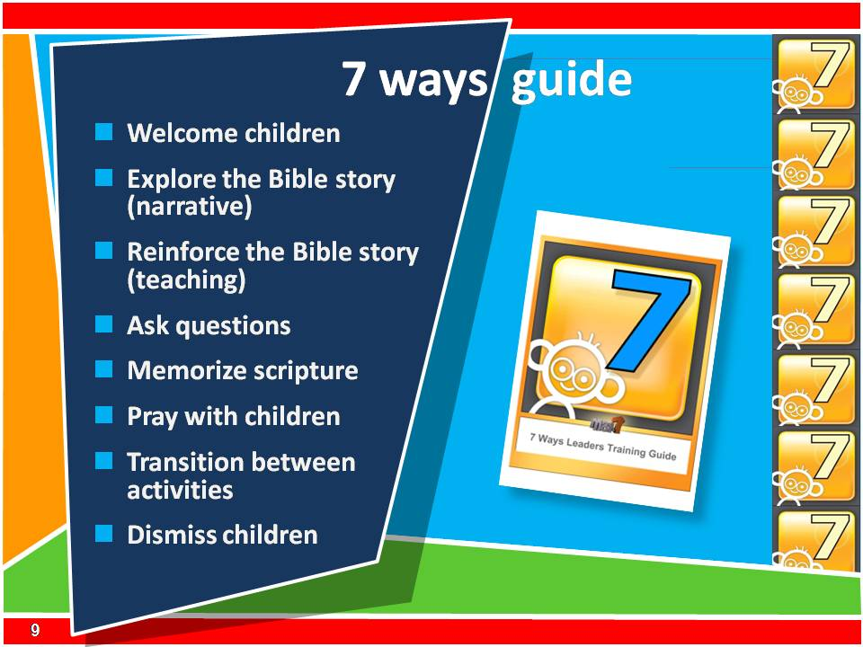
- Welcome children
- Explore the Bible story (narrative)
- Reinforce the Bible story (teaching)
- Ask questions
- Memorize scripture
- Pray with children
- Transition between activities
- Dismiss children
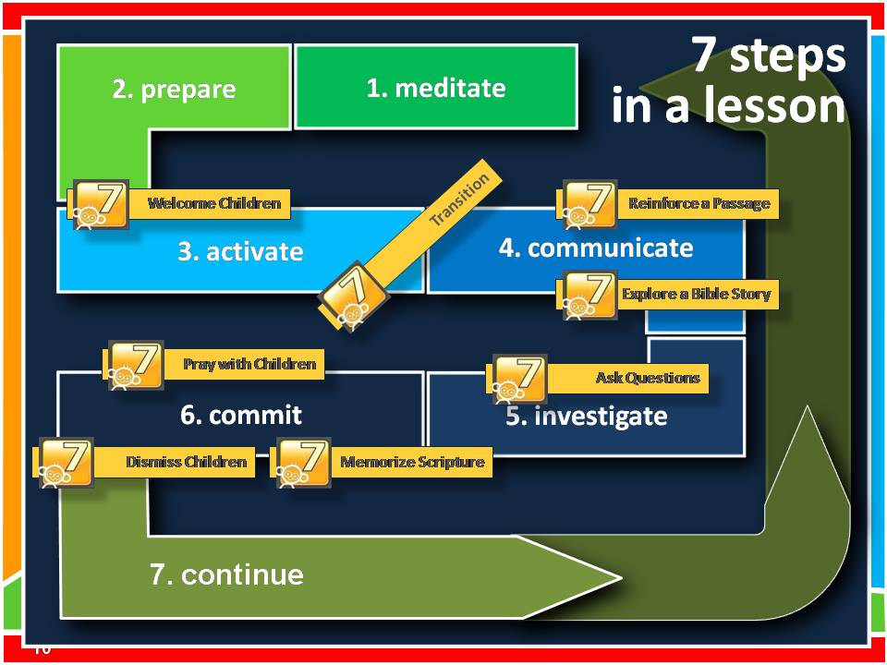
    - Show how 7 Ways links to the 7 steps
Show the lesson flow again and show how the ideas in the 7 Ways Guide give ideas for different parts of the lesson.

- 4. Leaders toolbox 15 min

The leader is the most important resource in a group. As a leader you need to think of your skills in terms of tools in a toolbox. The longer you have worked with children or teenagers, the more tools you will have in your toolbox. You need to deliberately sharpen you tools and continually learn new tools to put in you toolbox and use.
If you are a more experienced leader of children or teenagers you have an important job in mentoring younger leaders and help build their skills. Take some time to reflect on these questions by yourself.
- What skills do you have?
- What skills do other leaders have? How can you use them all effectively?
- How can you put more tools in your toolbox?
- Which junior leaders am I helping?
- What tools do you need in your leadership team? (Your option is to find a new leader with those skills or train a leader to have those skills)
- 5. Personal reflection 5 min
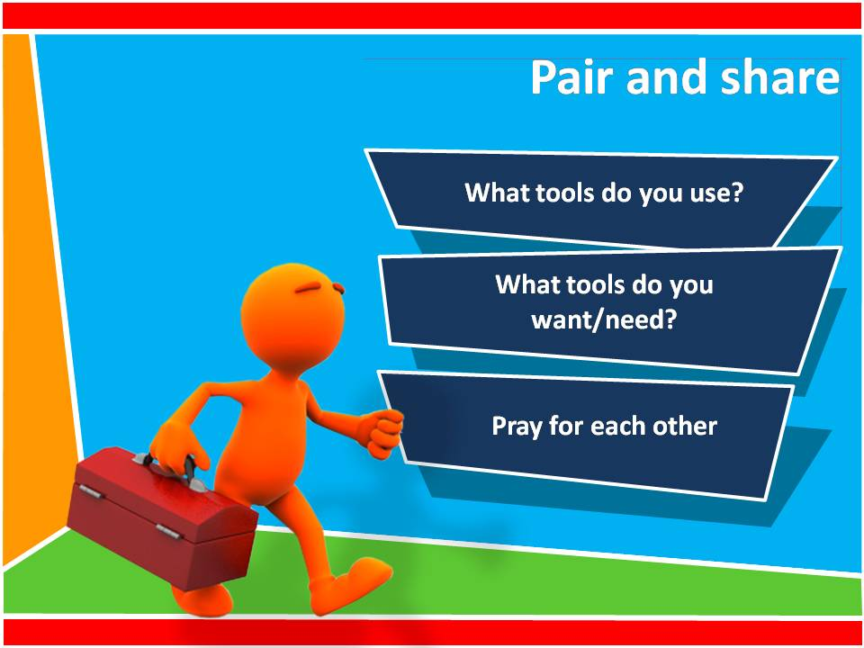
    - Pair and share
Ask the participants to find someone they have not worked with yet.
- What tools do you already use with children or teenagers?
- What tools do you want/ need?
- Pray for each other.

    - END of session M.2.

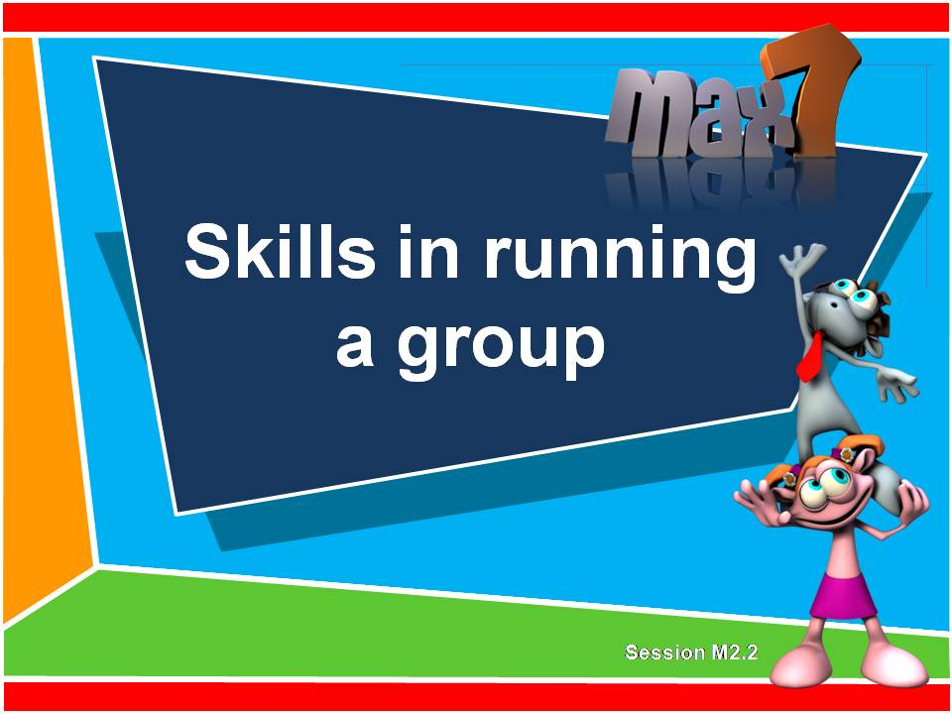
M2.2

Skills in running a group

90 minutes

Outcome

At the end of this module participants will have specific skills in working effectively with groups of children or teenagers.

Steps in the lesson

1. Disciple children or teenagers with firm love 30 min

2. Practice good listening and effective questioning 20 min

3. Be prepared 20 min

What you will need
- Bibles
- Worksheet
- Video projector and sound
Skills in running a group
Training program
- Discipline children or teenagers with firm love 30 mins
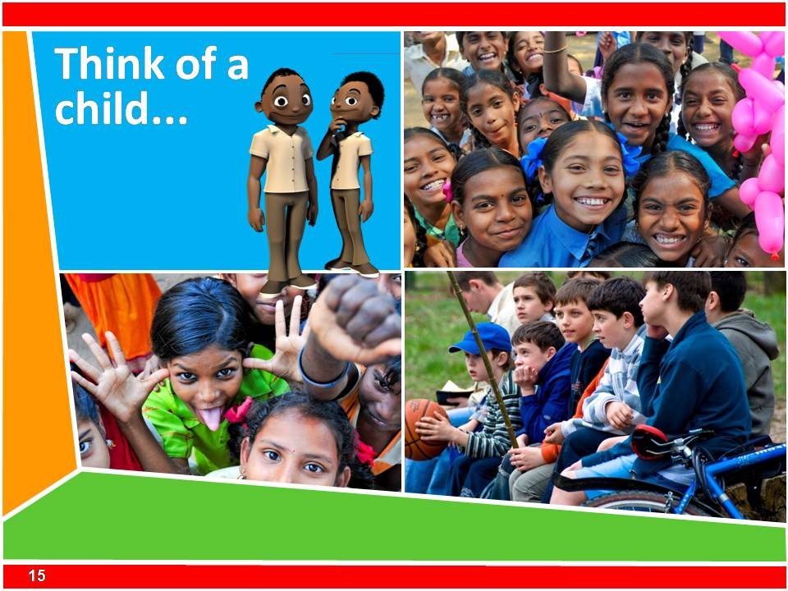
    - Stop and think of a child
Write down the names of one or two difficult children or teenagers that you teach now or have taught in the past. They may be difficult because they are naughty or disrupt others, they may be very different to you, you may be jealous of them or maybe they usurp your leadership and make you feel out of control. As we work through this session, keep these particular children or teenagers in mind.
    - Disciplining a child is an act of love
Disciplining a child is an act of love. The word discipline comes from the word disciple, which means ‘to learn.’ Discipling and disciplining a child is all about helping them to learn and grow. So when we discipline a child, the focus should be on helping them grow, not just seeking justice through punishment. Discipline is different from punishment.
As you talk about each of these following 7 points with the group, demonstrate the principles with the participants so that everyone understands fully and can see it being modeled. PPT
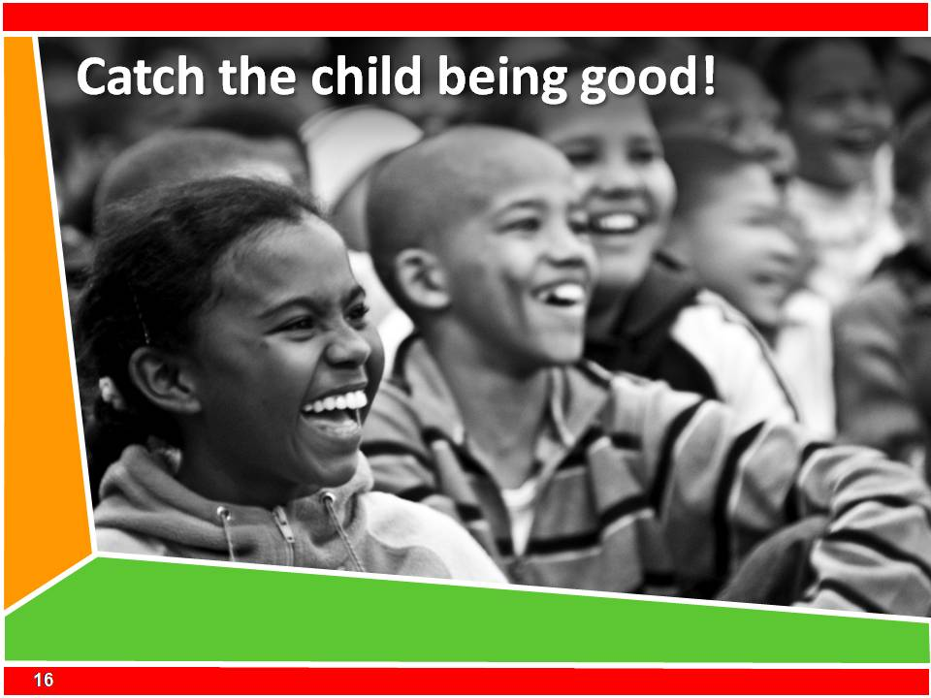
- Catch the child being good.
It is far more powerful to encourage good behavior than punish bad behavior. Make your group a positive place for children or teenagers to be and tell them that you really love their enthusiasm and cooperation. When a leader is speaking to the group always encourage all children or teenagers to listen and not talk or whisper to each other. If a child speaks, pause and look at them. They will usually stop talking so that you can go on. Encourage the rest of the group who are listening so well. Training children or teenagers to respect you by listening when you speak is fundamental to discipline.
To demonstrate this:
Make encouraging comments to individuals in the group as you are explaining the concept. Try to use people’s names. For example; ‘Thanks for listening so well Pedro’, ‘You have had some wonderful ideas to share today Sarah’ or ‘ You have waited so patiently for your turn in the game Isaac.’
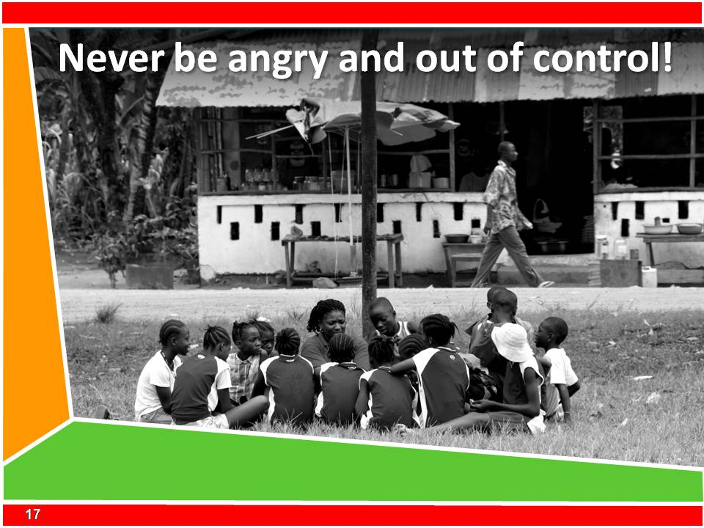
- Never be angry and out of control.
Do not shout or be violent. All young people will respect you less as a leader. It is often best to lower your voice and speak firmly and more quietly than to shout louder and louder. If you are angry and feel aggressive, it is best to leave the situation until another time or have another leader talk to the child at that time.
To demonstrate this:
As you speak to the group lower your voice and speak more deliberately to show how to use this is a powerful communication tool. It will show that you ‘mean what you say.’
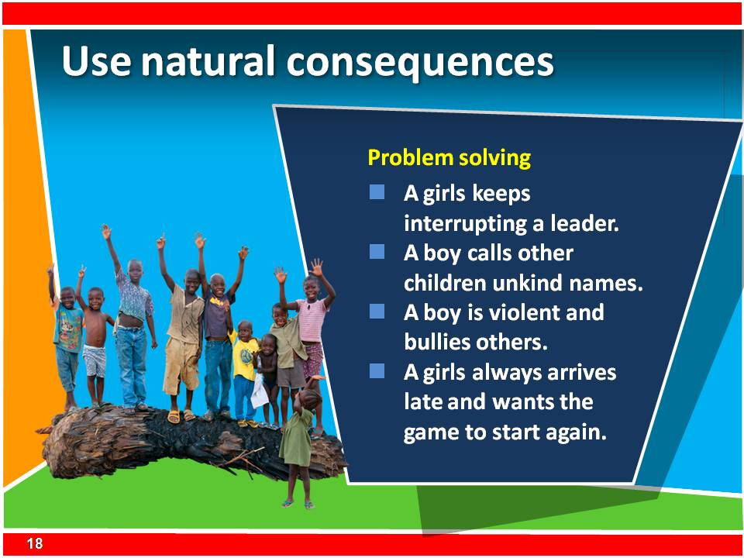
- Use natural consequences.
Instead of ‘punishing’ a child, find natural consequences for any negative behavior. For example if a child is being disruptive in a game, ask him/her to sit at your side out of the game until the game is finished. If they say rude and discouraging things to another child, they will need to sit out of the activity and think of 3 positive things about that child, and then apologize. This way they can think about the consequences of their behavior. Make a list of ‘rules’ for the group at the beginning of the year or term with all the children and young people present. Write those rules on a board in the room to remind all the children and young people. These are some examples of rules: listen to others, respect the property and space of others, make the group fun for everyone and be a helper and tidy up after yourself. When you talk to a child about their poor behavior it is good to show them the rules that they agreed to.
Pair and share
Think of a natural consequence which could be appropriate for each of these misbehaviors:
- A girl keeps interrupting a leader when they speak.
- One boy calls another boy some unkind names during a game.
- A boy is violent and bullies another smaller boy over a number of weeks.
- A girl is always late and wants to stop the game and start again when she has arrived.
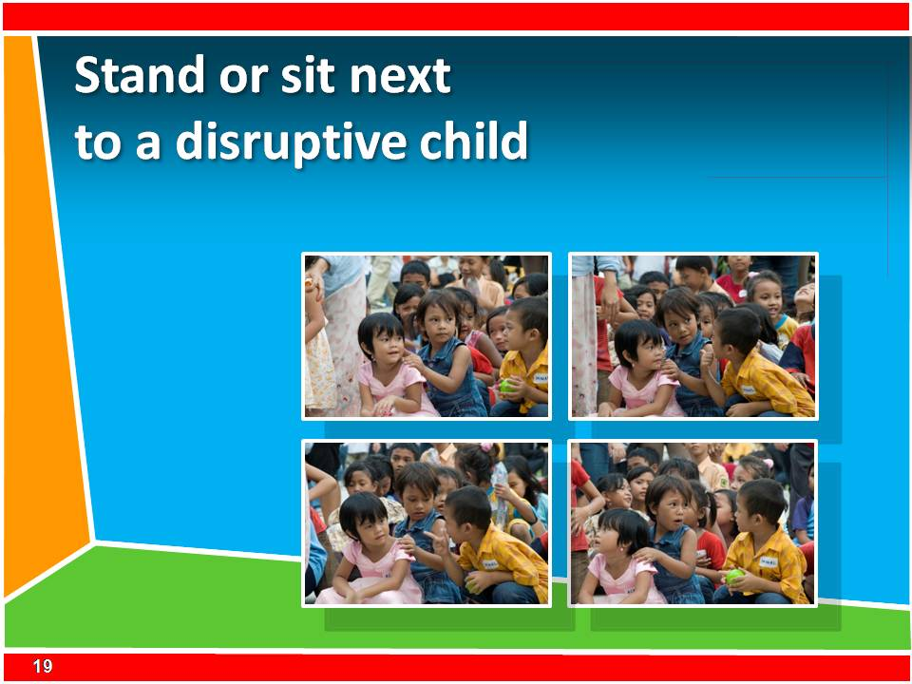
- Move close to disruptive children
If a child is being naughty or disruptive, have one of the leaders stand beside the child to help them focus on doing the right thing. Sometimes the leader will not have to say anything because just their presence close by will be enough to stop the disruptive behavior. If you have to speak to the child it is better to speak quietly and remind the child alone about their responsibility to the group. If you shout at a child from the front about their misbehavior they are getting attention in the wrong way. Also ensure that all the leaders model good listening when someone else is talking at the front.
To demonstrate this:
Walk around the room and stop beside anyone who is talking or whispering to each other while you are speaking. Draw attention to what you are doing.
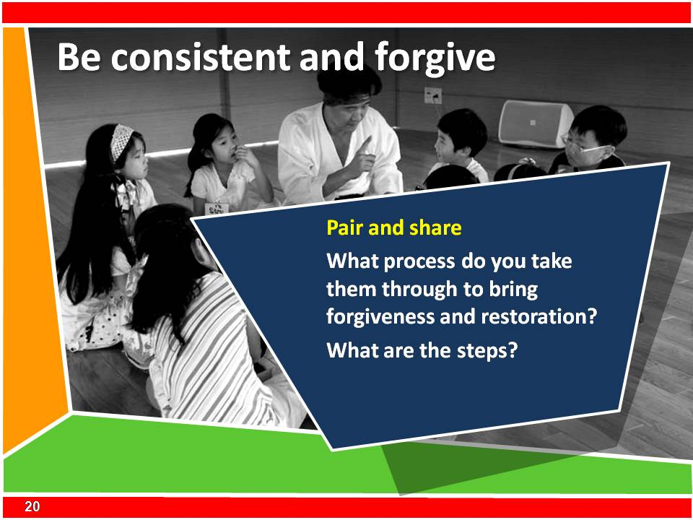
- Consistency and forgiveness.
It is not the toughness or severity of the punishment that is most important, but the certainty in the child’s mind that there will be a consequence for their bad behavior. Then after the child has had the consequence for that poor behavior, allow the child to apologize to you and anyone else involved. Make sure you forgive them and tell them. Let them know that the whole situation is fixed now. Modeling this is the best way to teach the child this important process of restoration and forgiveness.
Pair and share:
What process do you take children and young people through to bring them to forgiveness and restoration? What are the steps?
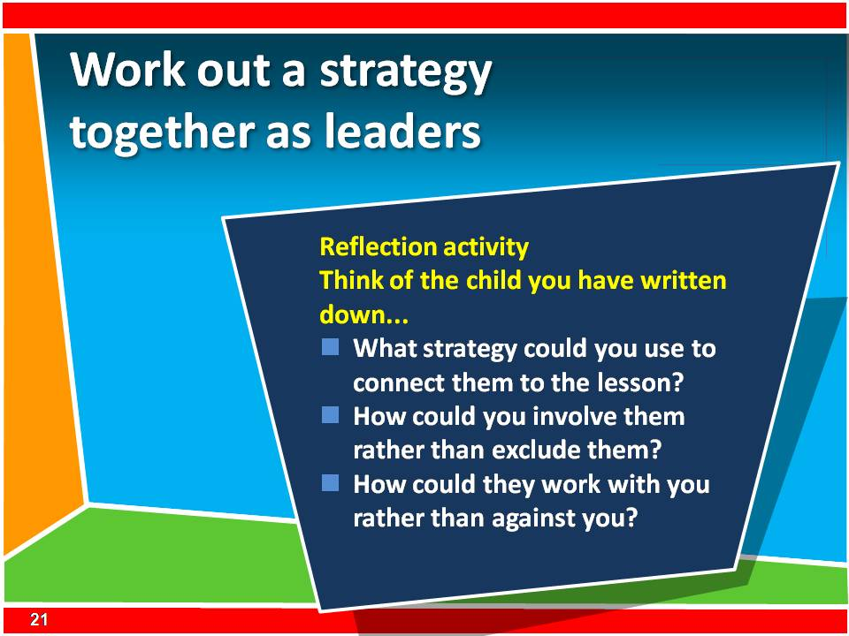
- Work out a strategy together as leaders.
Meet together as leaders and work out a strategy together for any children and young people with behavioral issues. Which leader may have a better connection with that child? Can a leader speak to the child before the lesson and give the disruptive child some important tasks to do in the lesson. Think of ways to help make the disruptive child become your best helper. Try to foresee problems and think of a strategy before the problem becomes big. Sometime ‘best friends’ who sit next to each other can become distracted. Ask them to sit apart in certain parts of the lesson such as the Bible story time. Pray for these difficult children or young people together.
Think of the child you have written down.
- What strategy could you use to connect them to the lesson?
- How could you involve them rather than exclude them?
- How could they work with you rather than against you?
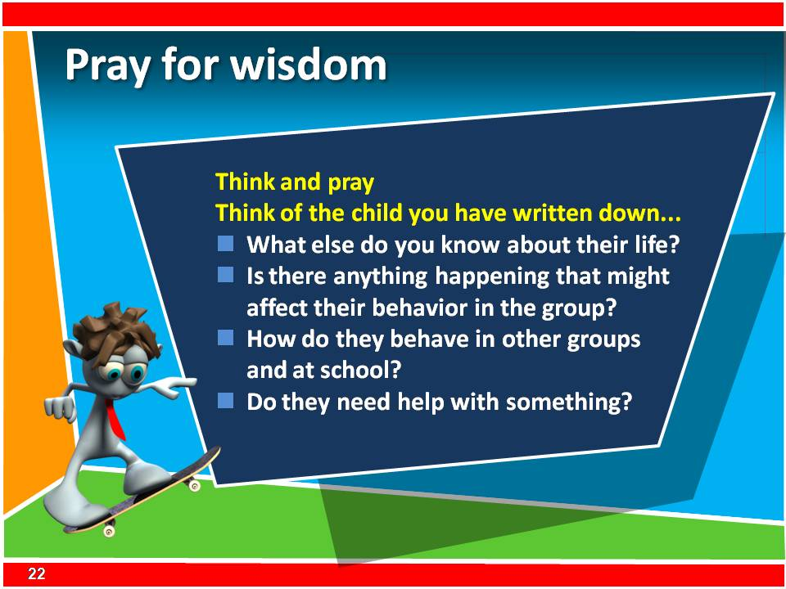
- Pray for wisdom.
A misbehaving child may be seeking attention for many reasons. Their behavior may simply be mischief, or it may be a cry for help. Ask yourself these questions. What else is going on in the child’s life? Is the lesson boring? Do they have friends in the group? Are they being bullied? What is happening with their family? Are they hungry or tired? Pray for them and pray that you would have wisdom to discern what to do to help them.
Think of the child whose name you have written
- What else do you know about their life?
- Is there anything happening that might affect their behavior in the group?
- How do they behave in other groups and at school?
- Do they need help with something?
    - Pair and share with a partner
Talk about the children or young people you have been thinking about and then pray for them now.

- Practice good listening and effective questioning 20 mins
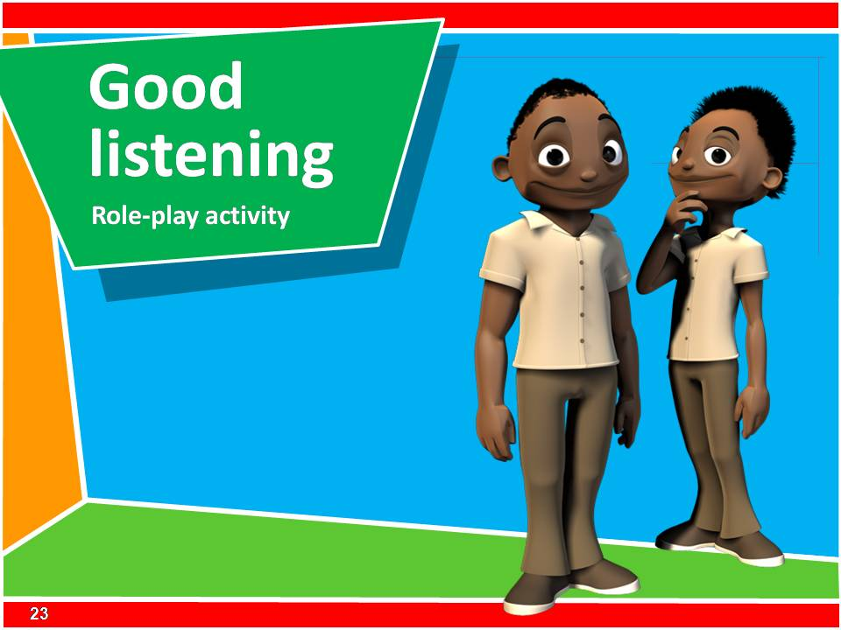
    - Good Listening
Leaders need firstly to listen to God and we have explored this already today. Leaders also need to listen to others especially to the children or young people they are journeying with.
    - Role Play
Prepare two leaders to role play the following:
One leader is talking with the other, in an excited and passionate way, about some experience that they have enjoyed recently. The other leader looks disinterested by looking at their watch, looking away, waving at friends walking by, etc.
Debrief the role pay by asking the group if they saw good listening taking place.
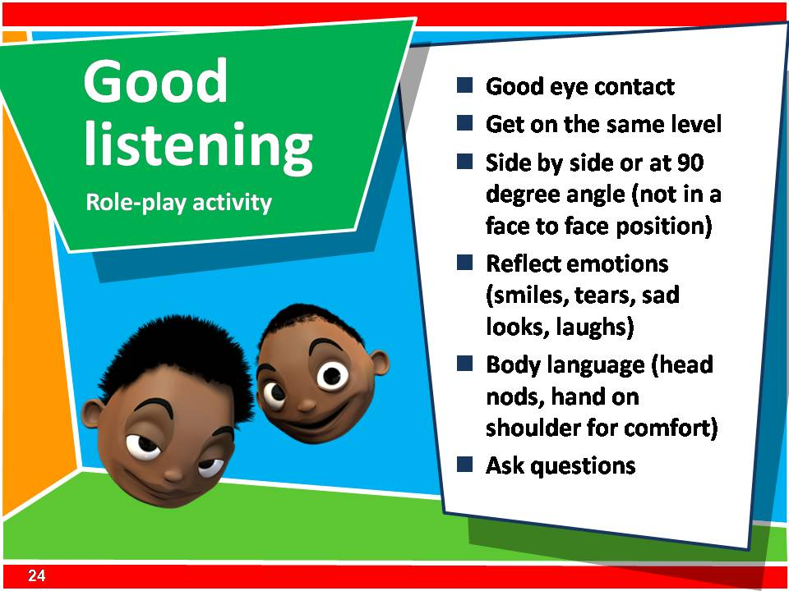
Talk about these points :
- Good eye contact
- Get on the same level
- Side by side or at 90 degree angle (not in a face to face position)
- Reflect emotions (smiles, tears, sad looks, laughs)
- Body language (head nods, hand on shoulder for comfort,)
- Ask questions
    - Pairs
Invite people to pair off. Decide who will talk and who will listen. Invite the talkers to tell their listener about an experience in their lives and to look for signs that their listener is using ‘active listening’ skills. After a time, swap roles.
Debrief the activity.
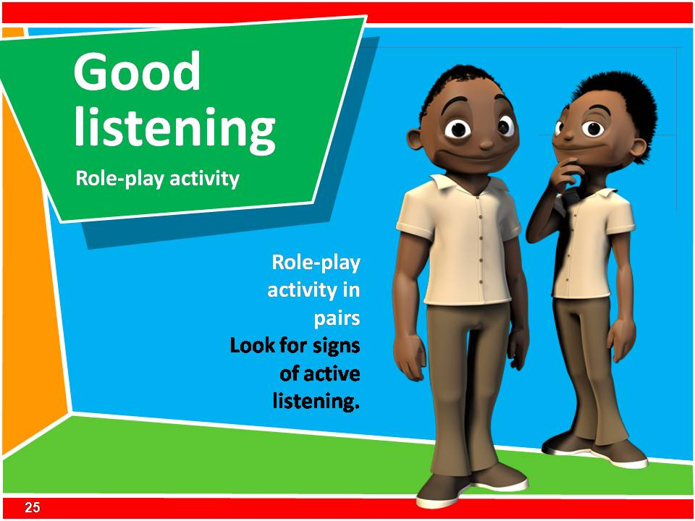
    - Role Play
Prepare two leaders to role play the following:
Two leaders meet and one begins asking the other a series of questions which are all ‘closed questions’ e.g. How are you today? Did you go to the mall yesterday? Did you buy anything? Did you see a movie? What as the name of it? Was it good? Did you see the new show on TV last night? It was great, wasn’t it? etc.
Debrief with the whole group. Point out that closed questions do not extend thinking and do not give any indication of feelings, or understanding or events or experiences.
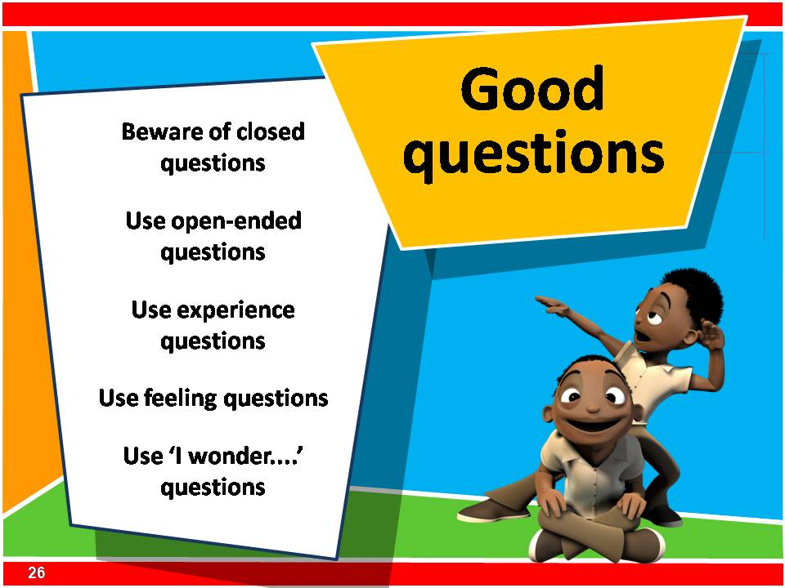
    - Questioning
Talk about these points:
Beware of closed questions
Useful for quizzes and competitions. Use of fact questions only can lead to children or young people thinking that faith is like a comprehension test where they have to get the answers right.
Use open ended questions
Cannot be answered with only one or two words. Questions that begin with ‘How’ and ‘Why’ will almost always begin an open ended question e.g. How did Jesus calm the storm? Why did Jesus feed the 5000 people that day?
Use experience questions
These connect the experience of the story being explored to the same experiences of the children e.g. Who has ever been in a boat? Who has been in a storm? Tell me about a time when you were really hungry?
Use feelings questions
How were you feeling when the storm was at its strongest?
Use ‘I wonder’ questions
e.g. Jesus at the grave of Lazarus. The crowd had gathered. Mary and Martha were there. Lazarus had been dead for 4 days. There was a bad smell. “I wonder what Jesus is going to do? ‘I wonder’ questions do not require an answer but engages everyone’s thinking about the question.
Summary: Plan for these questions to be included in your programs and in your conversations with children or young people.
- Be prepared 20 mins
    - Energizer
Play a short, fun game.
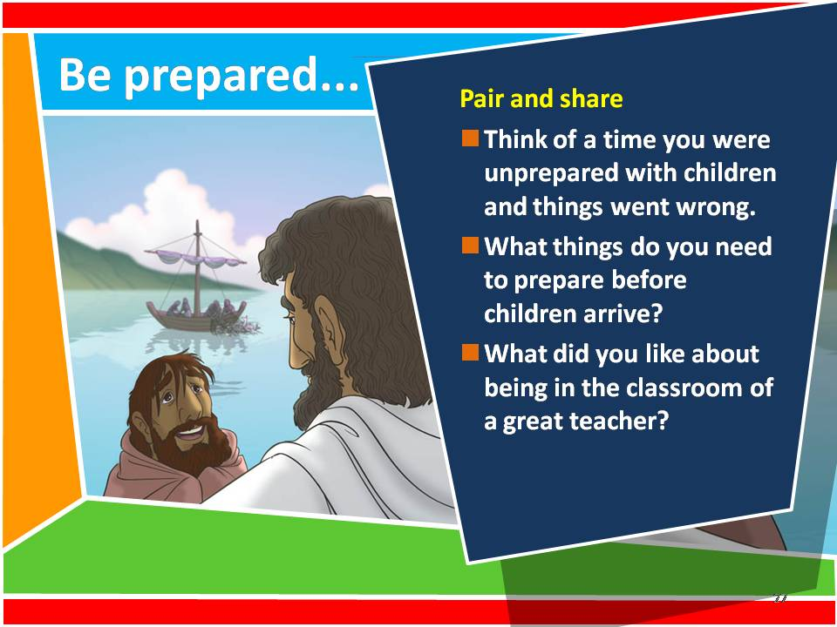
    - Pair and share
Talk to a partner about a time you were extremely unprepared for a lesson with children or young people.
    - Brainstorm
- What are the things that need to be prepared before the children or young people arrive?
- What did you like about being in a classroom of a great teacher when you were a child?
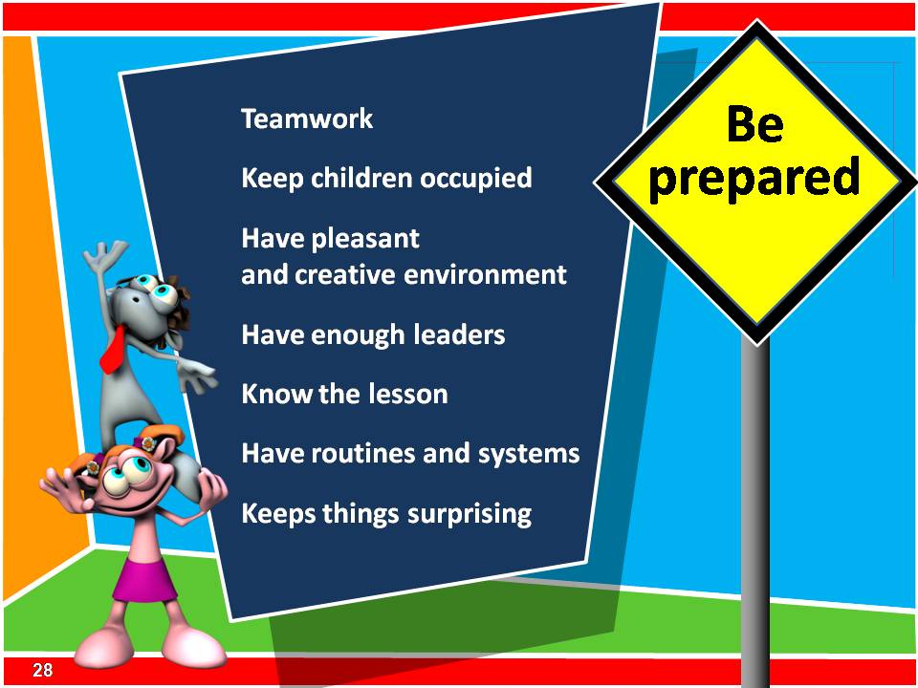
    - Explain how to be prepared for children
There are some important things to understand when working with a group of children or young people. Much of the success of how the group operates, how the children or young people learn and how you feel as a leader is all about being prepared. There are many ways to be prepared. Lets think about these for a moment.
Teamwork. Prepare and plan the lessons with the other leaders. Know what all your roles are in the group. Who leads games? Who leads each of the small groups? Know the strength of each other. You will have seen the teamwork we use in training you in this group.
Keep children and young people occupied. Prepare more activities than you will need for the time with the children. If the club goes for 1 hour, have an extra 20 minutes of games and activities ready. Things are always unpredictable. Sometimes an activity cannot be completed and so you will have to drop it or replace it. Sometimes the times of the club will change. Always keep children or young people busy. If there is nothing for them to do they may become bored and mischievous. A team of leaders who are working together smoothly will keep children moving ahead, flowing from one activity to the next seamlessly.
Environment. Prepare a pleasant and appealing environment for children or young people to come into each week. Think about the friendliness of people and the attitudes of leaders. Also think about the physical arrangement of the room or hall. Are there things that will constantly distract children or young people? Does it all look appealing? Are there enough seats if you want children or young people to sit on chairs? Are there bright colors?
Have enough leaders for the group. As a general rule it is best to have at least one leader for every 10 children. So if there are 58 children in the club you really need to have 6 or more leaders. This will help with the safety and management of children.
Know the lesson. Prepare the lesson thoroughly. As a leader, know what practical things that you are doing in the lesson. Collect all the resources that you need such as balls, blindfolds and chalk. Prepare for the lesson by reading meditating on the Bible passage and by praying for the children or young people and leaders in your group.
Have routines and systems. Children get a great deal of security from knowing how things will work in the group. They need to understand what is important and what rules they need to obey. This keeps things fair and simple for children. The expectations of the group should not change each week if different leaders are rostered on to take different aspects of the lesson. Children or young people should know who is in charge, who they should see if they are hurt, where the offering money goes, and where they should meet together.
Keep things surprising. This point will balance the one before. When children and teenagers feel a sense of security and belonging then surprises are exciting. Don’t always do things the same way. This will bore children or teenagers and leaders. The 7Ways guide helps you add variety and surprises into the program you run. Always have fun with children and teenagers.
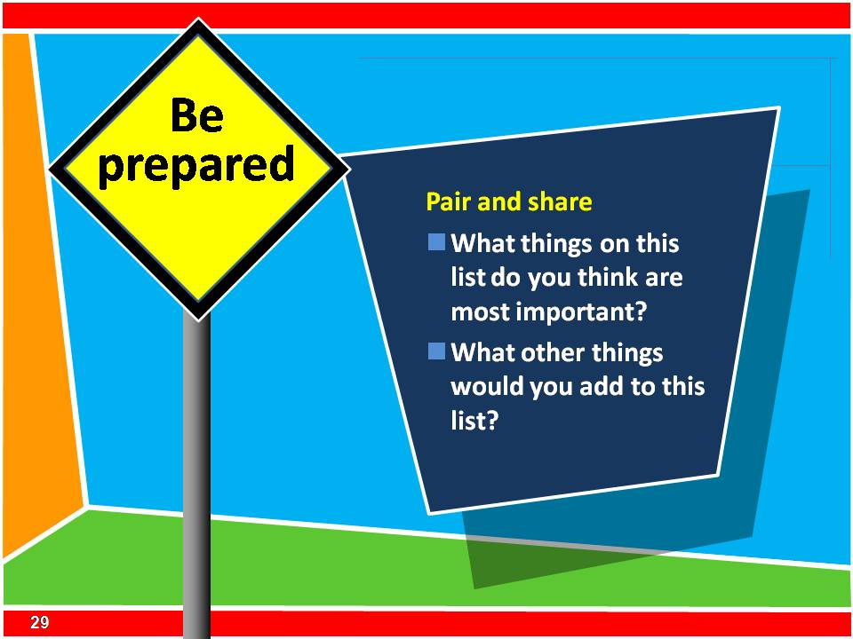
    - Pair and share
- What things on this list do you think are most important for you to remember?
- What things would you add to this list?


    - END session M2.2

